Loan a Device Design Document
DRAFT
Date | Version | Author | Status
30/09/16 | 0.1 | Ruth Awojobi | Active

Version | Date | Author | Amendments
0.1 | 30/09/16 | Ruth Awojobi | Creation, Initial draft for review
0.1.1 | 05/10/16 | Ruth Awojobi | Continued Creation, Initial draft for review
0.2 | 06/12/16 | Ruth Awojobi | Update Documentation with UI, updated user journey and changes to user stories due to functionality changes (after review with Syl)

Version | Date | Reviewed by | Comments

Version | Date | Outstanding Issues

Name | Date | Sign Off
Syl Omope | 06/12/16

Loan a Device Design Document 1
1.0 Introduction 3
1.1 Purpose 3
1.2 Scope 3
1.3 Definitions and Abbreviations 3
1.4 Circulation 4
1.5 Assumptions 4
1.6 Risks 4
1.7 Dependencies 4
2.0 High-Level Architecture 5
3.0 Web Application Functionality and Design 5
3.1 My Page (Landing Page) 5
3.1.1 Overview 5
3.1.2 Functional Requirements 5
3.1.3 Wireframe 7
3.2 Devices 9
3.2.1 Overview 9
3.2.2 Functional Requirements 9
3.2.3 Wireframe 10
3.3 Menu 12
3.3.1 Overview 12
3.3.2 Functional Requirements 12
3.3.3 Wireframe 12
4.0 Application wide Specifications 13
5.0 User Journey 13
6.0 Data Model 14
7.0 Process Flow 14
8.0 Appendix 15

1.0 Introduction
Being a Software House, FSI purchase and test on most of the latest mobile devices to ensure its product is fit for purpose before taking it to market. FSI’s development department constantly use mobile devices as part of their day to day working activity and it can sometimes be difficult to keep track of each devices whereabouts.
The current process is a paper based one, whereby, a personnel within the development department writes their name, the device name and date in which the device has been taken on a piece of paper and then simply places a tick next to what was written when the device is returned.

1.1 Purpose
The aim of this Loan a Device Design Document is to provide a requirement documentation which will be to develop the device management (namely ‘loan a device’) web Application by an offshore development team.
This design document is intended to describe the functional requirements needed to develop this application in the form of User Stories (US) and UI design screens, for the development of the Application. Each US will have a set of Acceptance Criteria’s (AC) which will assist with the write up of the test cases and form the basis for UAT to enable sign off of that particular US. . Wireframes will be included to convey the desired look and feel of what is to be built, which then will be interpreted and designed by UX/UI developer to deliver the actual designs of what is to be built.
In addition to the UI/UX designs and US, the design document will also provide; User journey/ Screen navigations Process flows, data models, and workflow information to assist the offshore team in their work.

1.2 Scope
The scope of this document is to initially build a device stock management application which allows FSI personnel to easily access self-check-in /out and device location. In the first instance, development will look to fulfil the phase 1 core requirements further enhancements will be made to this web application in Phase 2/ 3 after the successful completion of this phase.

1.3 Definitions and Abbreviations
- US –User Story
- AC –Acceptance Criteria
- EFM –Enterprise FM team
- Dreamscape – This is the platform upon which all web applications will be built

1.4 Circulation
- EFM team
- Any changes, update or amendments made to this document must be circulated to the author and agreed with Syl Omope.
- This document is the only living document for the duration of the project therefore, requirements contained herein are subject change in order to meet business needs.

1.5 Assumptions
- Employee information will be accessible via a plug-in from the Data Object table within the dreamscape platform.
- It is assumed that the team in place would be able to deliver this project within the set timeline.

- That the product that would be delivered will fulfil all of the phase 1 core requirements except where stated and will be fit for purpose.

- That the phase 1 Loan a Device application is expected to be a stand-alone application and would not be dependent on any other back-end system

1.6 Risks
- This web application will be built by a new offshore team who are still developing their knowledge of the platform. This may impact the deliverables and delivery time for this project as they will require additional support during the development phase of this project.

- As the Dreamscape Platform would be used to build this Application, it should be noted that the functionalities requested, may not all be readily achievable based on the limitations of the platform.

- All requirements that cannot be included in this phase (Phase 1), would be estimated and included in the next phases (Phases 2/ 3).

- Encountering bugs and blockers in the Dreamscape Platform may cause delays in delivering this project on time.

1.7 Dependencies
None

2.0 High-Level Architecture
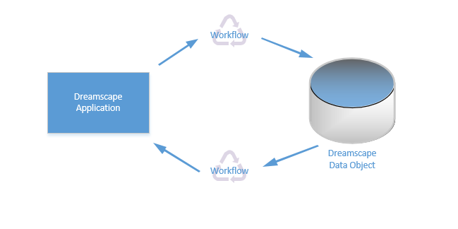

3.0 Web Application Functionality and Design

3.1 My Page (Landing Page)

3.1.1 Overview
My Page’ is the default tab which the user will first see once accessing the application. The ‘My Page’ feature will be the most interactive part of the application, where users will be able to ‘Loan Device’ and ‘Return Device’ as well as see a history of the users last 3 devices on loan.

3.1.2 Functional Requirements

Theme | us-ID | As a/ an | I want to… | So that… | Acceptance criteria
My Page | 001 | All Users | Be presented with the Home/Landing page once my password have been entered | I know I am in the right application | * The user must be able to see information which allows them to ‘Loan Device’ and ‘Return Device’.  *User must see information on the last 3 devices on loan  *User must be able to see the number of devices s/he currently have out  *Maximum device on loan is 2 per user (in the event where user has more than 2 on loan, user will not have the option to Loan a Device and a flag will appear stating this).
My Page | 002 | All Users | Be presented with my name in the welcome message within the home/landing page | I know the application has brought back data concerning my profile | *Home page must display a welcome "USER"
My Page | 003 | All Users | Be able to Loan a device | The application can update the device records in order for another personnel to use | *A data list with the headings ‘Device’, ‘On Loan’ and ‘Returned’ must be displayed with information on users last 3 loaned devices  *User must be able to see and select a ‘Return Device’ button  * The table will be ‘read only’ populating data from the application.  *The ‘On Loan’ and ‘Returned’ columns must have a date stamp triggered when the ‘On Loan’ and ‘Returned’ button is selected
My Page | 004 | All Users | See a confirmation message once I have returned a device | I know the system has acknowledged my request | *confirmation message dynamically appears
My Page | 005 | All Users | Be able to loan a Device | The application can update the device records so other personnel are aware the device is no longer available | *User must be able to choose a device from the dropdown  *Once the device is selected, the application must be able to automatically set a return date visible for the user to see  *The return date must not be 2 working days from when the device has been loaned out  *User must receive an email the morning the device is due back *Validation must be displayed if user attempts to select ‘loan device’ without selecting the device  *User must be able to see and select a ‘Loan Device’ button (precondition- user has not exceeded the limit of 2 devices on loan).
My Page | 006 | All Users | See a confirmation message once I have returned a device | I know the system has acknowledged my request | *confirmation message dynamically appears
My Page | 007 | Administrator | Be able to add a device to the Device list | The application will have an up to date account of what devices are available for use | *Permissions are set to only allow a Manager/Approved user to be able to see and select the 'Add a Device' button  * the page will consist of 3 text boxes whereby the administrator can insert ‘Device Number’, ‘Device Model’ and ‘IMEI Number’ followed by a save button.  *Once the information is inserted and saved, the page should navigate back to the ‘All Devices’ tab.  *when the back button is selected on this page, the information is abandoned and unsaved.

3.1.3 Design Screen- My Page
Screen 1 and 2 represents the page the user will be directed to once logged into the application. The ‘My Page’ tab is the default tab which shows the last 3 devices the user has loaned giving them an option to return the device or loan a device. Screen 1 is the user’s view whereas, screen 2 is the administrator’s view whereby the administrator has an additional button called ‘Add Device’ in order to update Device catalogue.

Screen 1

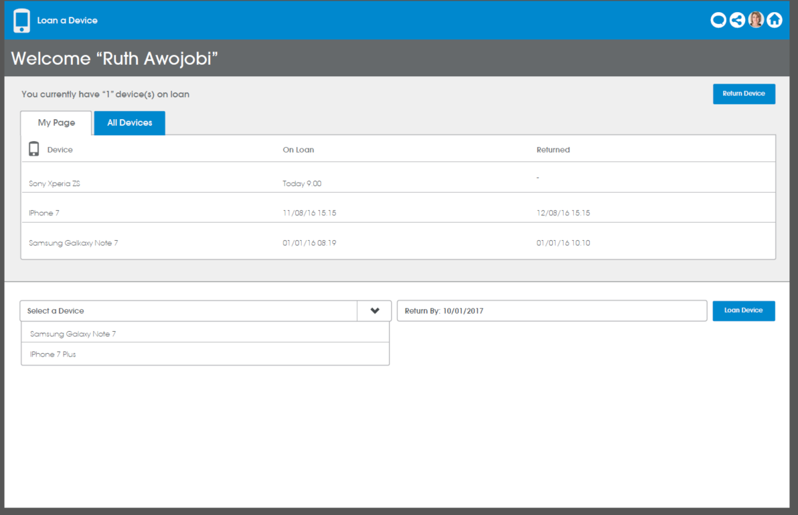

Screen 2

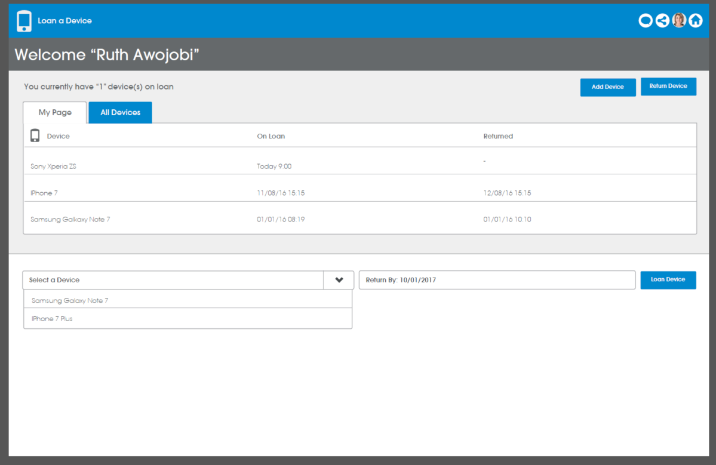

Screen 3 and 4 represents the confirmation message the user will receive once the ‘Loan Device’ button has been selected. Screen 3 is the user’s view whereas, screen 4 is the administrator’s view whereby the administrator has an additional button called ‘Add Device’ in order to update Device catalogue.

Screen 3

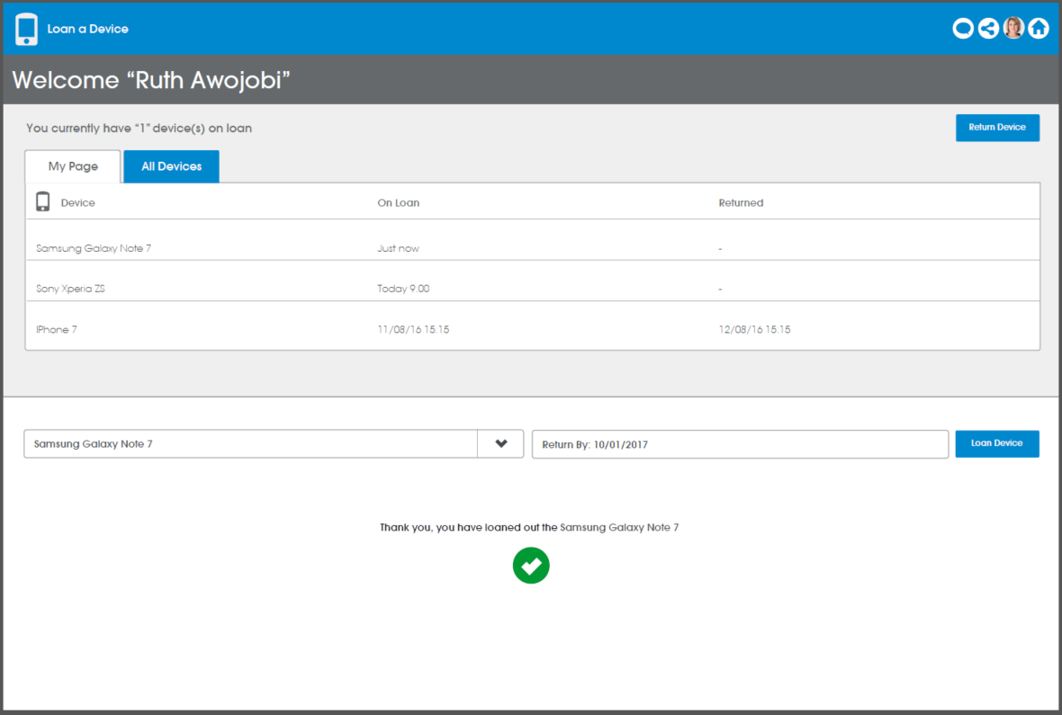

Screen 4

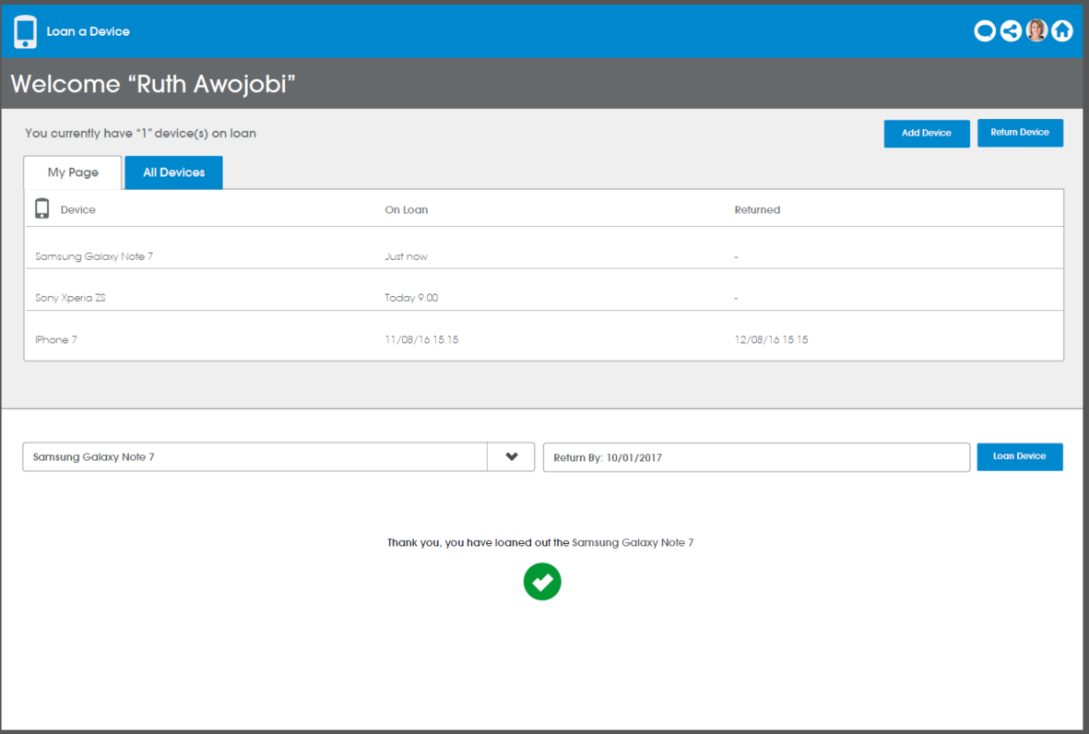

Screen 5 and 6 represents a scenario whereby a user has loaned out 2 devices at the same time. In this scenario, the user will not be presented with the option to loan a device but instead will see a notification message indicating that this. Screen 5 is the user’s view whereas, screen 6 is the administrator’s view whereby the administrator has an additional button called ‘Add Device’ in order to update Device catalogue.

Screen 5

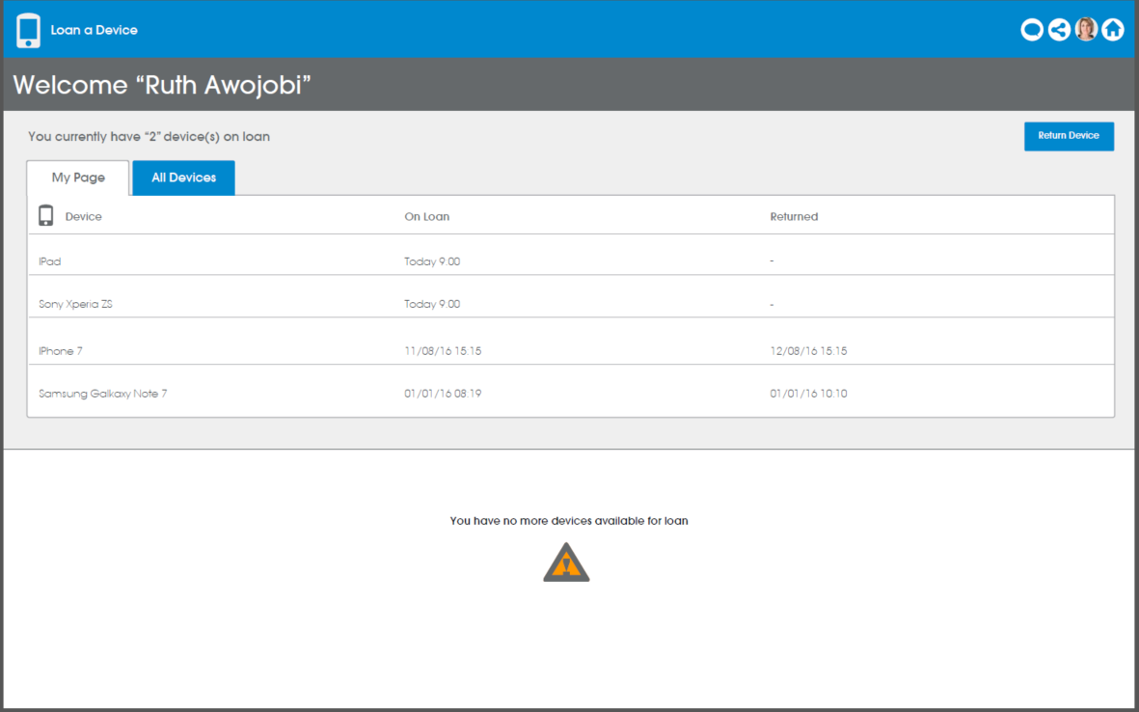

Screen 6

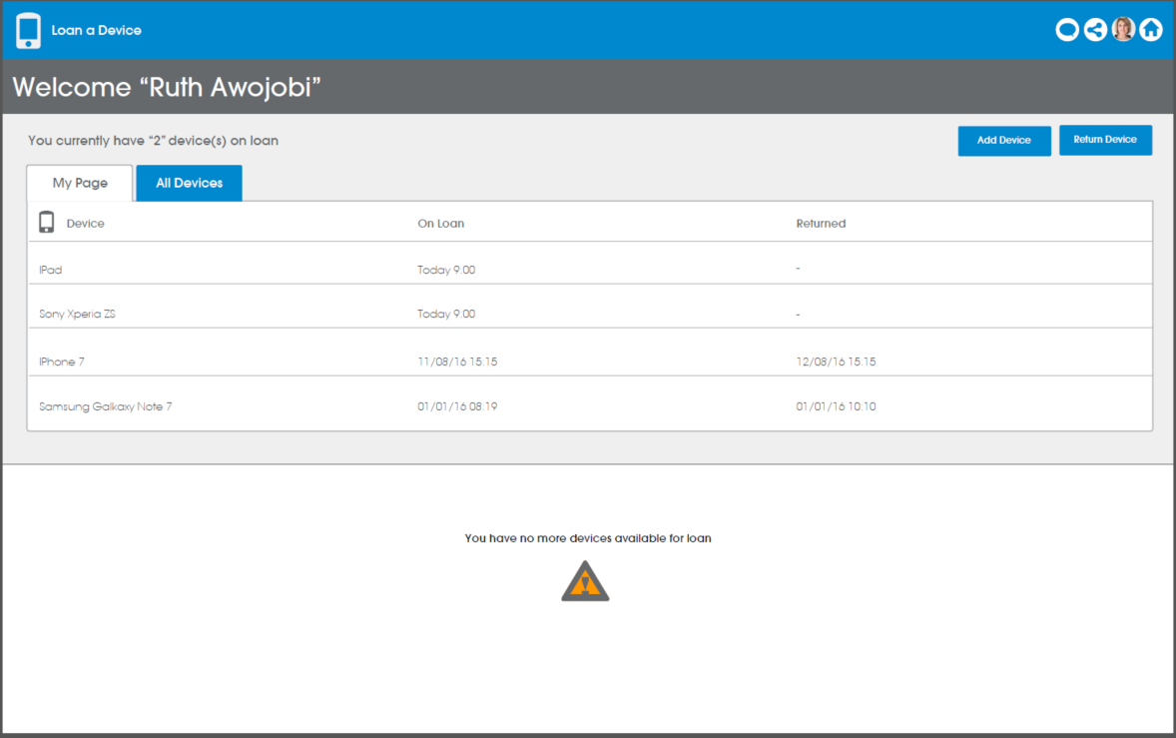

3.2 All Devices

3.2.1 Overview
The All Devices page is where all devices owned by FSI will be displayed in a data list. Here, the user will be able to see a table of devices and next to each will be information on its availability and where possible details of the personnel the device is on loan to.

3.2.2 Functional Requirements
Theme | us-ID | As a/ an | I want to… | So that… | Acceptance criteria
All Devices | 001 | All Users | Be able to see a list of each device owned by FSI and its availability status | I know who has the device and when it will be available | *Read Only Data list displayed with all devices owned by FSI along with; 'Device', Personnel who device is currently with (in the case where it's free, it will display N/A) and the devices projected 'Availability' (in the case where the device is available, it will display Now).
All Devices | 002 | Administrator | Be able to add a device to the Device list | The application will have an up to date account of what devices are available for use | *Permissions are set to only allow a Manager/Approved user to be able to see and select the 'Add a Device' button  * the page will consist of 3 text boxes whereby the administrator can insert ‘Device Number’, ‘Device Model’ and ‘IMEI Number’ followed by a save button.  *Once the information is inserted and saved, the page should navigate back to the ‘All Devices’ tab.  *when the back button is selected on this page, the information is abandoned and unsaved.

3.2.3 Design Screen- All Devices & Add Device
Screen 1 and 2 represents the page the user will be directed to once the ‘All Devices’ tab is selected. The ‘All Devices’ tab is a read only data list of all devices owned by FSI. Screen 1 is the user’s view whereas, screen 2 is the administrator’s view whereby the administrator has an additional button called ‘Add Device’ in order to update Device catalogue.

Screen 1

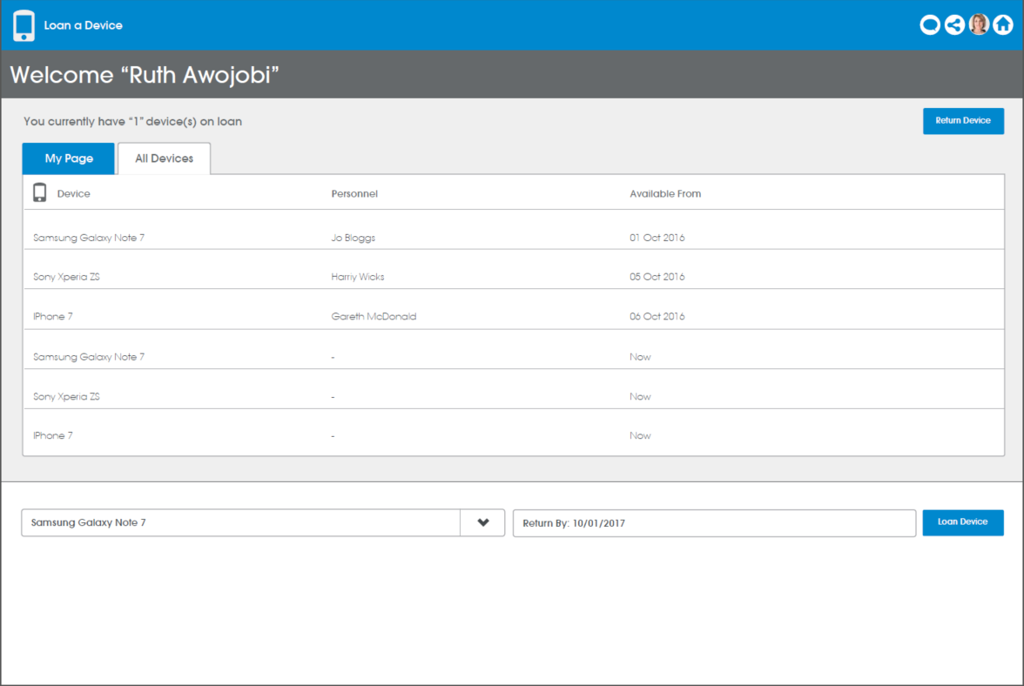

Screen 2

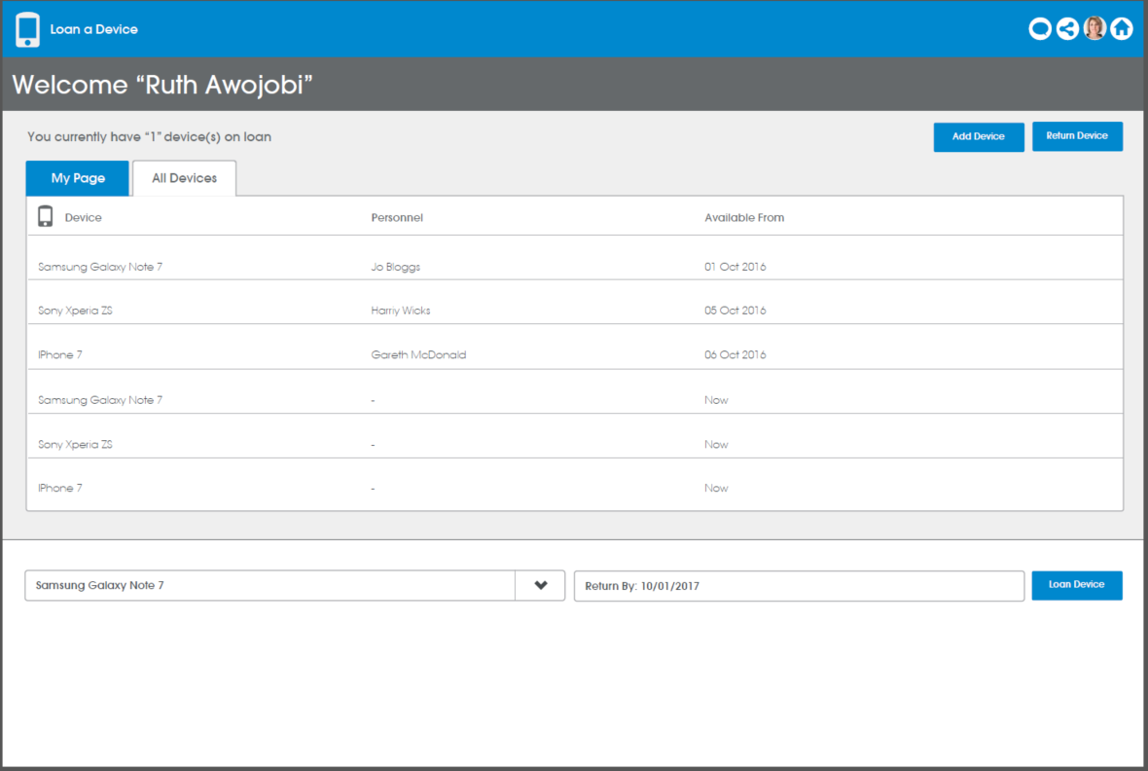

Screen 3 represents the page ‘Add Device’ page which is only available to an administrator. Here the page will consist of 3 text boxes whereby the administrator can insert ‘Device Number’, ‘Device Model’ and ‘IMEI Number’ followed by a save button.

4.0 Application wide Specifications
Devices – This application is expected to be used on multiple devices including Desktops, Tablets and Mobiles.

5.0 User Journey

5.1 End User’s Journey
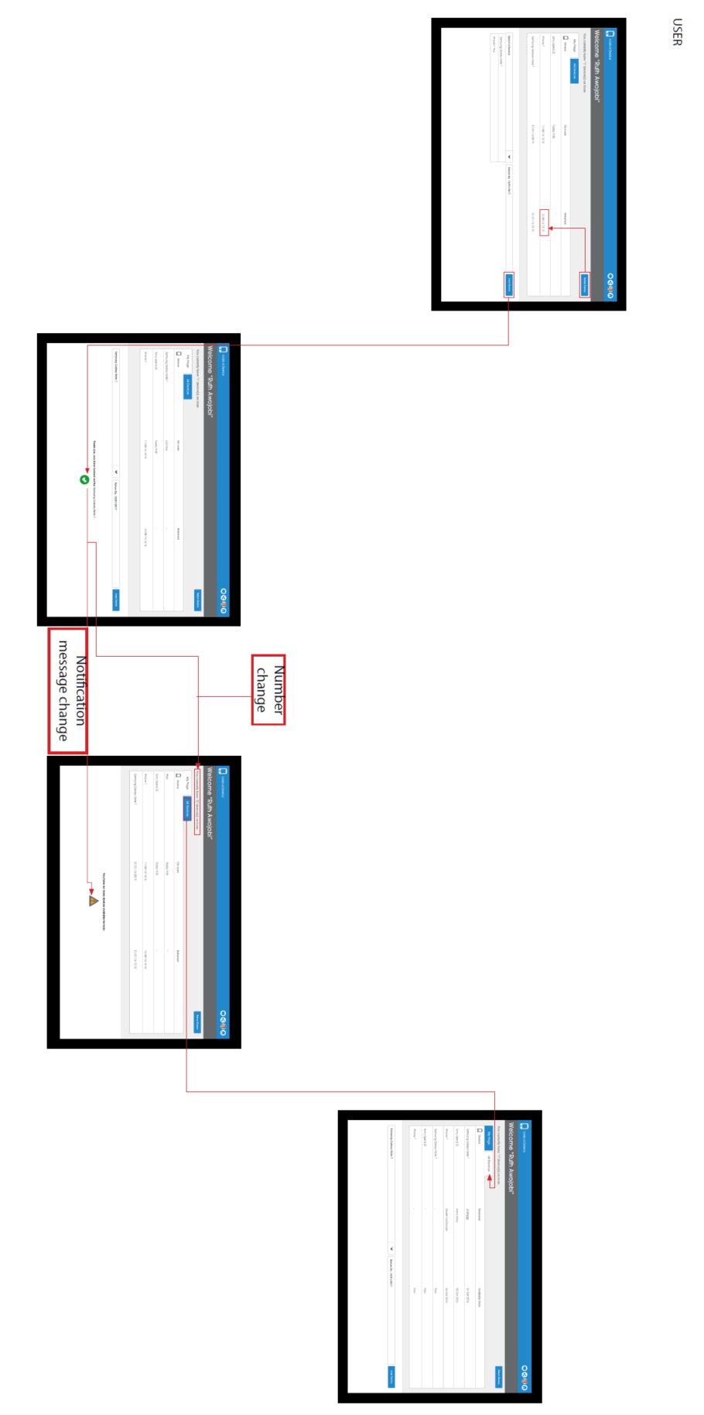

5.2 Administrator's User Journey
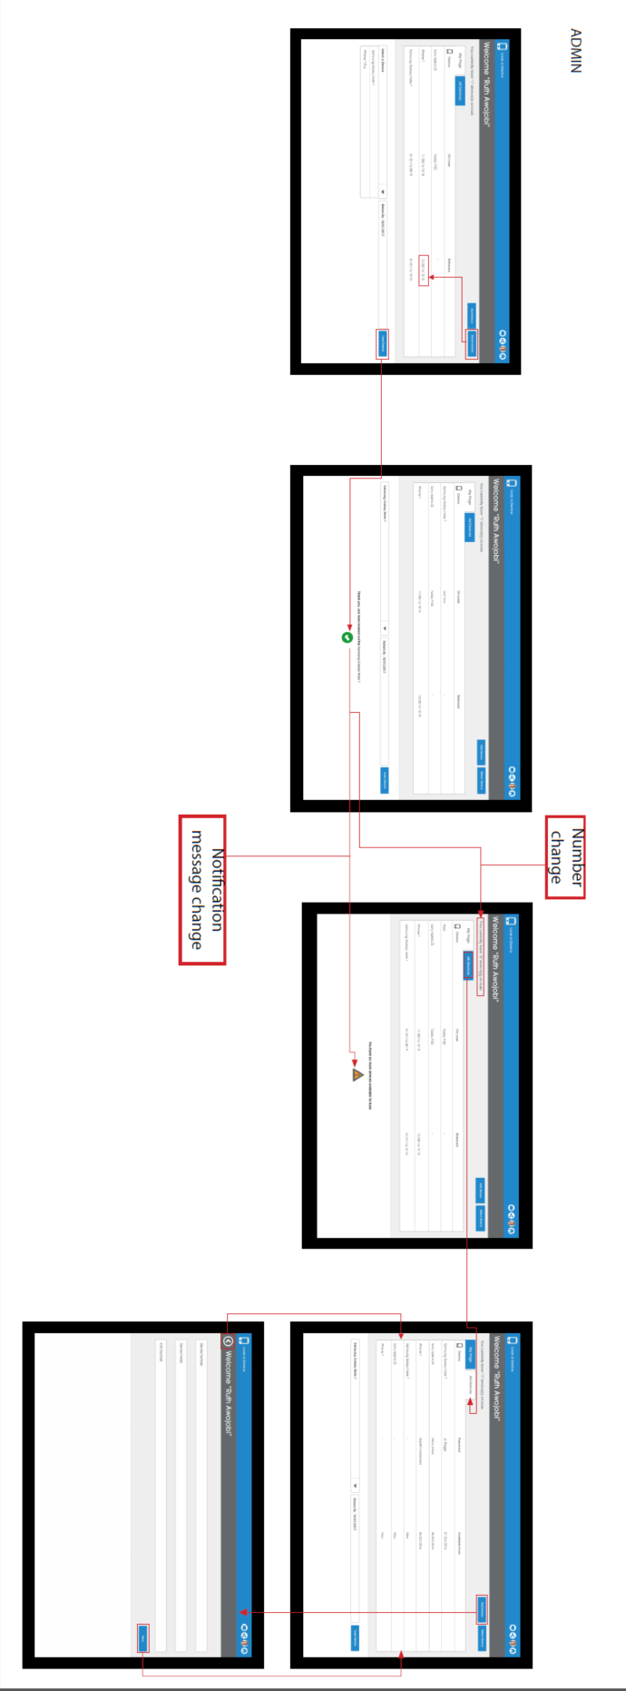

6.0 Data Model
TO BE INCLUDED

7.0 Process Flow
TO BE INCLUDED

8.0 Appendix

8.1 Wireframes (initial mock-up)

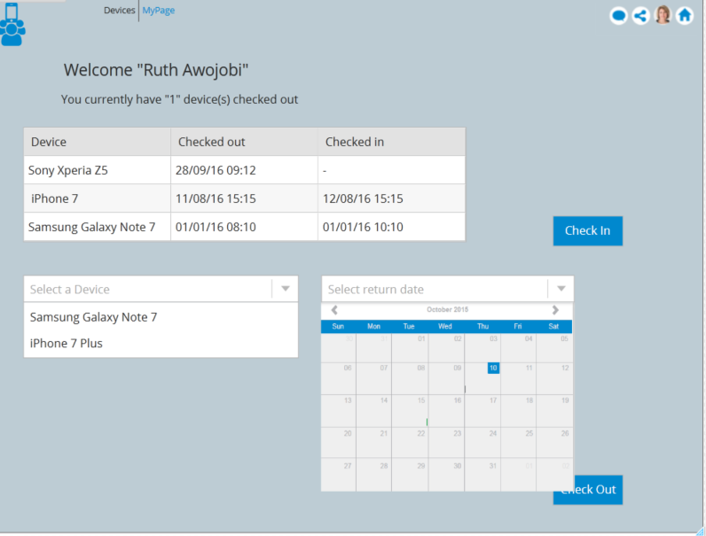

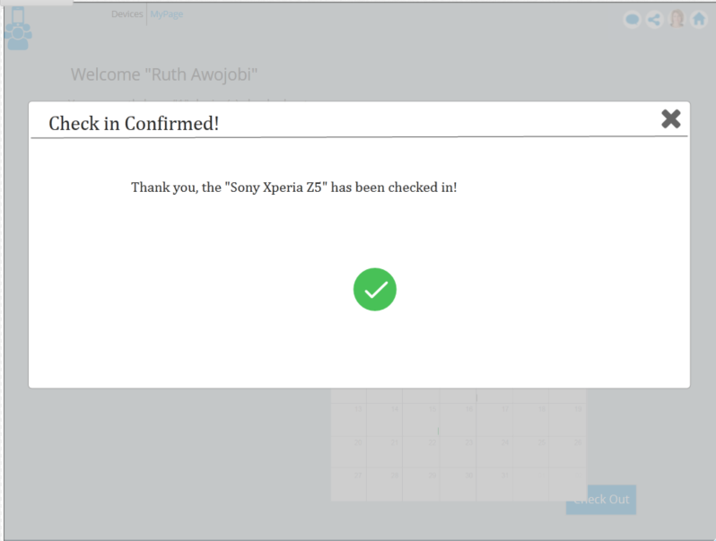

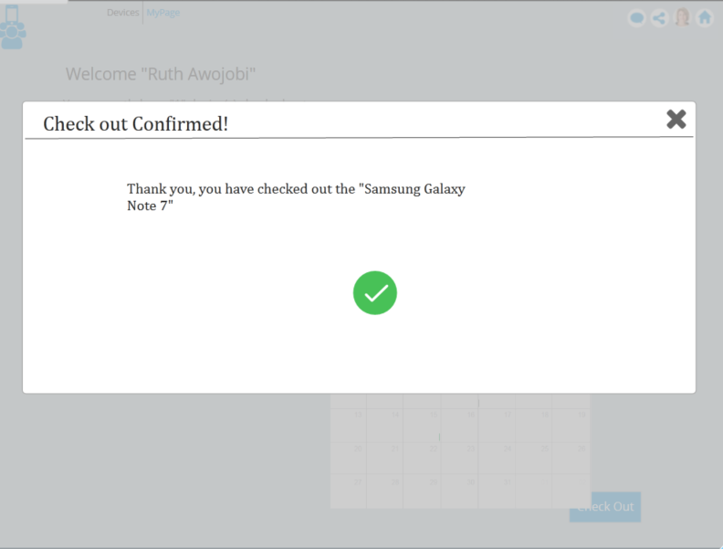

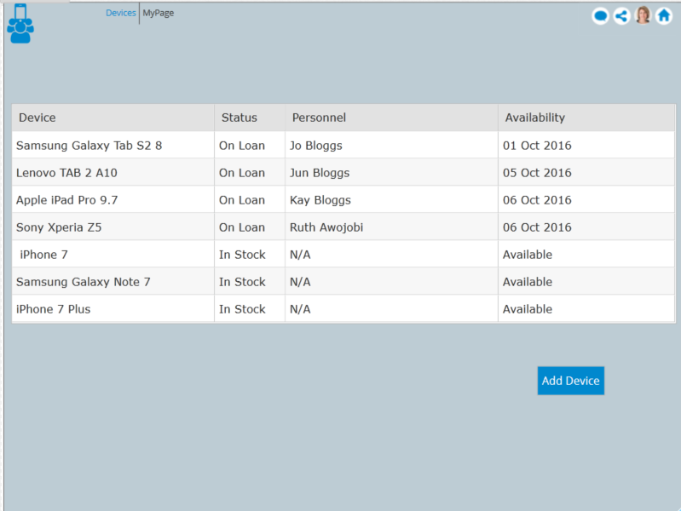

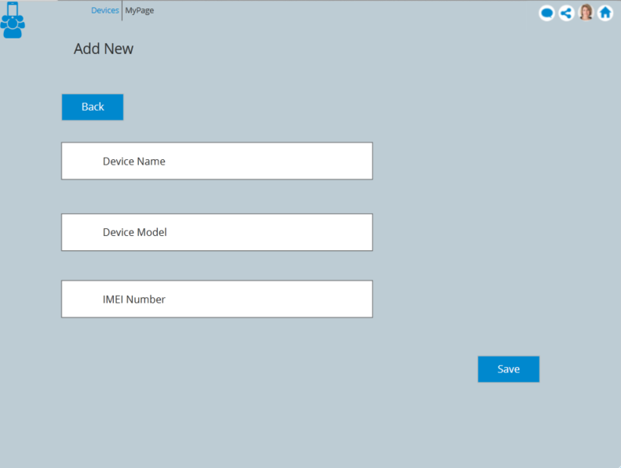

8.2 Initial User Journey (using wireframes)

